**OPTIMIZING THE BEST LOCATION FOR OPENING AN AYURVEDIC AND INDIAN ORGANICS STORE IN MANHATTAN, NYC**

**Introduction :**

NYC is the financial capital and the most populous city of the United States. I am from India and like many other Indians, I’ve used and continued to use many Ayurvedic remedies for various common and uncommon health and beauty issues. Ayurveda is a natural system of medicine which is 3000 years old. I wish to spread the magic of this “God’s gift to Indians” to the entire world, and what better place than NYC to start something like this.

It will be a clinic with highly qualified and experienced ayurvedic doctors. Along with the clinic, there will also be an Indian organics store which will have all sorts of raw, pure and unprocessed products which are used in ayurvedic remedies.

The target audience are the people who are fitness freaks, crazy about yoga and are aware of the cons of using processed and chemical-intensive products for health and beauty.

In this project, I will be optimizing the best location in Manhattan, NYC for maximizing the target audience for the clinic and store.

**Data used in the project :**

**Source for NYC data -**

https://cf-courses-data.s3.us.cloud-object-storage.appdomain.cloud/IBMDeveloperSkillsNetwork-DS0701EN-SkillsNetwork/labs/newyork_data.json

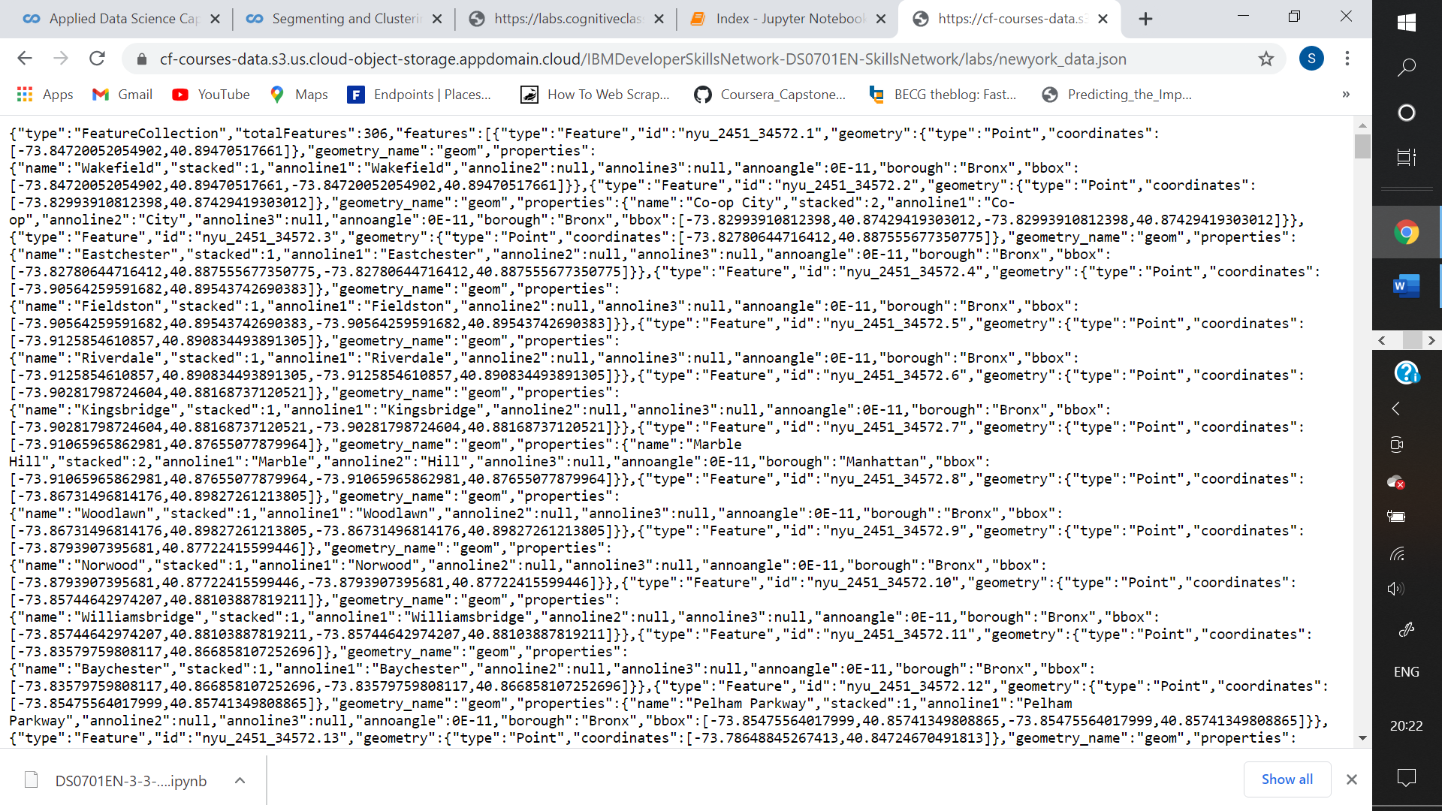

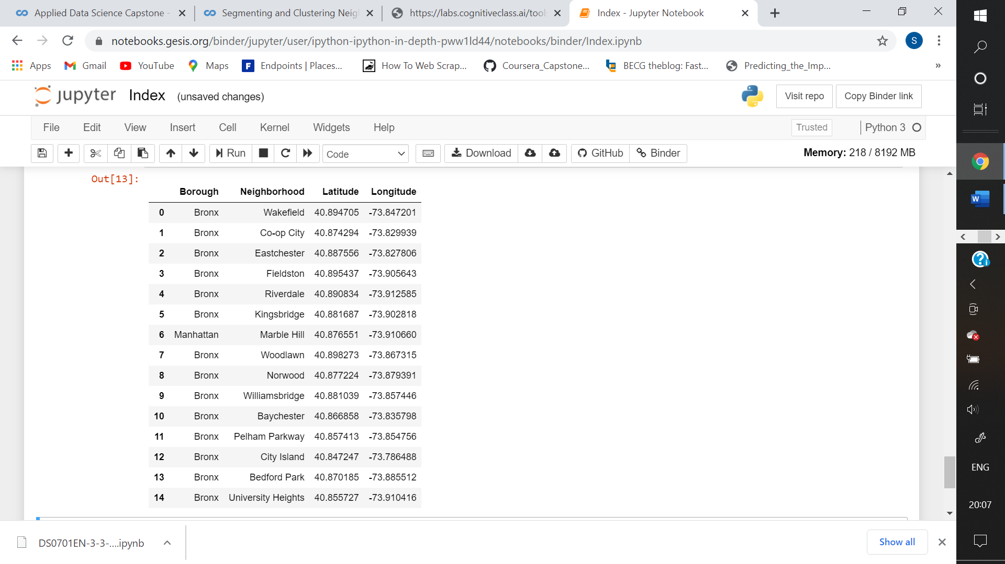

I used k-means clustering to form clusters based on the type/category of venues present in the locations. Analysing the clusters helped me in choosing a suitable location for opening an Ayurvedic clinic in NYC.